**Project Design Phase-II**

**Technology Stack (Architecture & Stack)**

|  |  |
| --- | --- |
| Date | 27 june 2025 |
| Team ID | LTVIP2025TMID59882 |
| Project Name | TrafficTelligence: Advanced Traffic Volume Estimation with Machine Learning |
| Maximum Marks | 4 Marks |

**Technical Architecture:**

The Deliverable shall include the architectural diagram as below and the information as per the table1 & table 2

**Reference:** [**https://developer.ibm.com/patterns/ai-powered-backend-system-for-order-processing-during-pandemics/**](https://developer.ibm.com/patterns/ai-powered-backend-system-for-order-processing-during-pandemics/)

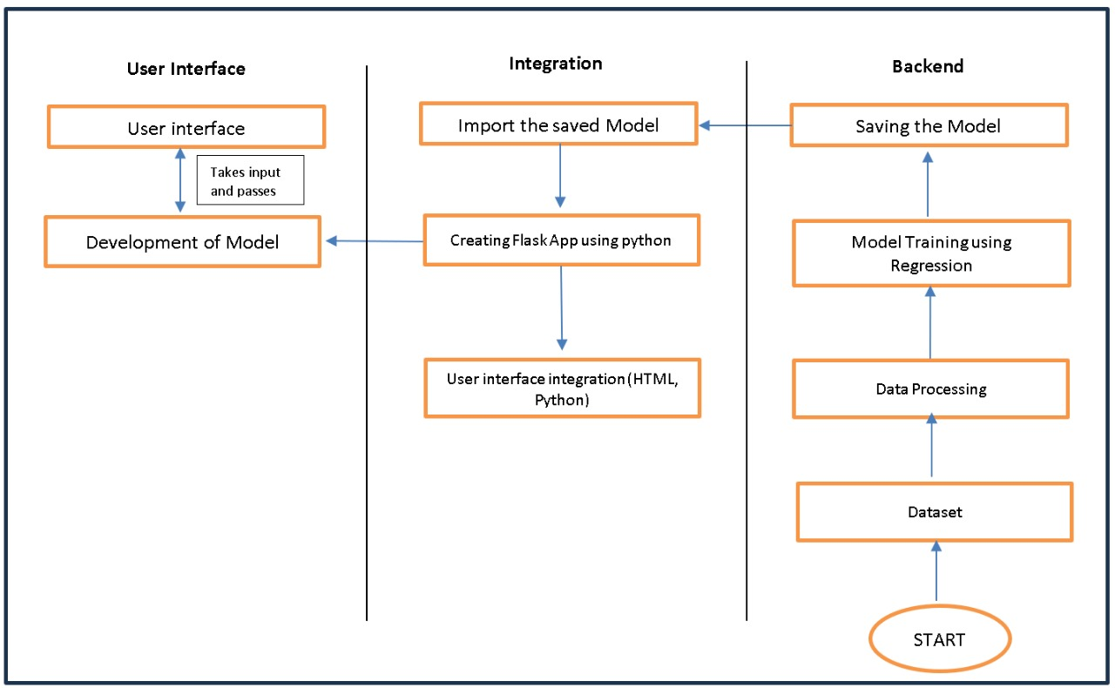

**Table-1: Components & Technologies:**

|  |  |  |  |
| --- | --- | --- | --- |
| **S.No** | **Component** | **Description** | **Technology** |
|  | User Interface | Critical element designed for both Traffic Managers and everyday users, ensuring an intuitive and informative experience. | HTML, CSS, JavaScript |
|  | Application Logic | Involves a robust backend system responsible for processing, analyzing, and managing traffic data. | Python |
|  | Database | Involves the storage and management of diverse traffic data for analysis. | File Manager, csv |
|  | File Storage | Involves managing diverse types of data, including raw traffic data, machine learning models, and configuration files. | Local System, Google Drive |
|  | Frame Work | It is a crucial part of our program as it is responsible for connecting the frontend with the backend. | Python Flask |
|  | Machine Learning Model | The machine learning model is responsible for predicting future outcomes based on available data. | Machine learning model created using regression algorithms |
|  | Infrastructure (Server / Cloud) | Involves a combination of servers and cloud services to support the computational and storage needs of the application. | Local |

**Table-2: Application Characteristics:**

| **S.No** | **Characteristics** | **Description** | **Technology** |
| --- | --- | --- | --- |
|  | Open-Source Frameworks | Using cameras to collect data and to make models for specific locations. | Python’s Flask |
|  | Scalability | Immediate classification of produce as healthy or rotten. | Computer vision, dynamic databases. |
|  | Performance | |  | | --- | |  |   Regular performance testing, monitoring, and optimization are integral components of the development and maintenance processes, ensuring that TrafficTelligence consistently delivers timely and efficient traffic volume estimations. | R squared, Root mean squared error, Root Mean Square deviation. |
|  | Availability | Website can be made available all time in a webserver. This makes the website running without any issues. | High speed Linux based webservers. |

**References:**

[**https://c4model.com/**](https://c4model.com/)

[**https://developer.ibm.com/patterns/online-order-processing-system-during-pandemic/**](https://developer.ibm.com/patterns/online-order-processing-system-during-pandemic/)

[**https://www.ibm.com/cloud/architecture**](https://www.ibm.com/cloud/architecture)

[**https://aws.amazon.com/architecture**](https://aws.amazon.com/architecture)

[**https://medium.com/the-internal-startup/how-to-draw-useful-technical-architecture-diagrams-2d20c9fda90d**](https://medium.com/the-internal-startup/how-to-draw-useful-technical-architecture-diagrams-2d20c9fda90d)